Crystal Senter Brown

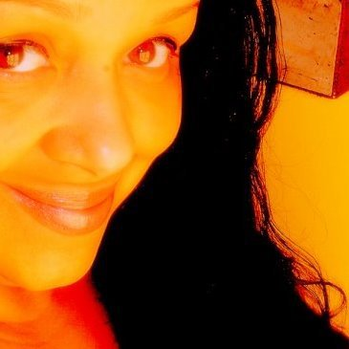
Crystal Senter Brown has appeared in Redbook Magazine, Vibe Magazine and Essence Magazine and has been a performer for most of her life. Born in Morristown, TN to a bass-playing Baptist preacher and a painter, Crystal was introduced to poetry at the age of six.
Since then, she has performed in thousands of events across the U.S. and Canada including the Berkeley School of Music, Smith College, Mt. Holyoke, University of Massachusetts, the NABFEME music conference, the Nuyorican Café in NYC, and more.
Crystal was awarded the 2010 Harold Grinspoon Award and the 2010 Massachusetts Cultural Council grant for her children's book Gabby Saturday . She is a graduate of Bay Path College in Longmeadow, MA.
Her poetry has appeared in The Women's Times, African American Point of View, The Valley Advocate, Local Buzz, Vibe Magazine, The Republican and His Rib.
She released her first novel The Rhythm in Blue in January, 2012.
When she's not writing, performing or saving the world, she lives in New England with her husband Corey, son Adonte and a potato chip-eating dog named Serena Marie.

