Author, Speaker, Screenwriter, Teacher
Crystal Senter-Brown

Book List
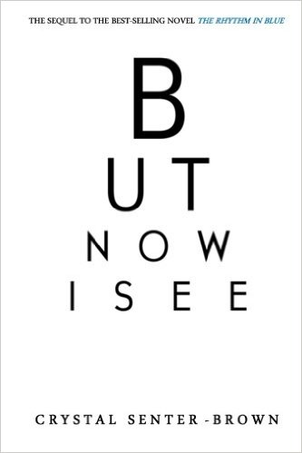
But Now I See
Fiction Novel, ISBN# 978-1500964962
Jasmine doesn’t care how she got Mason, all that matters now is that her dream of becoming his wife is finally coming true. Everything seems to be perfect, until she receives a delivery of dead flowers and a cryptic note on her wedding day. Is someone trying to end her marriage before it even begins?

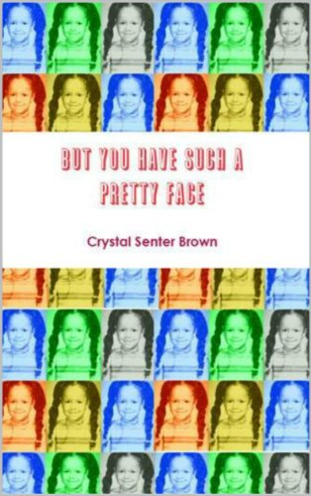
But You Have Such a Pretty Face
Poetry, ISBN #978-1497418141
“But you have such a pretty face” is divided into five sections: When I think of Home (poems about growing up in Morristown, TN), Love (poems about love and relationships), The Weight is Over (poems about size-acceptance and learning to love the body you’re in), Sisterhood (poems for women and girls) and Endangered Species (poems for men and boys.) .”

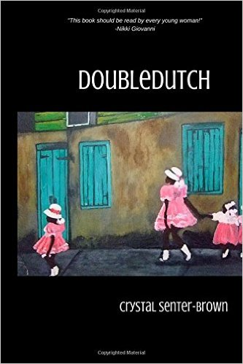
Doubledutch
Poetry, ISBN 978-1530848430
Doubledutch is the first collection of Crystal Senter Brown, and all poems included in this book were written between 1996 and 2006. Some poems are biographical, others are simply observances. Doubledutch skips through topics everyone can relate to: Love, parenting, relationships, poverty, employment, solitude, dieting, size acceptance, cheating hearts and everything in between.

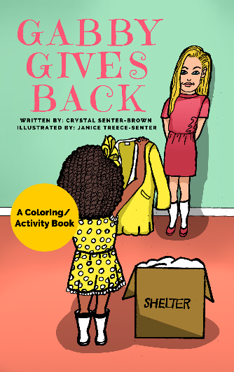
Gabby Gives Back
Children’s book, ISBN #978-1523254224
Daddy is teaching Gabby an important lesson about giving to others in need by taking her to a local soup kitchen/ homeless shelter.

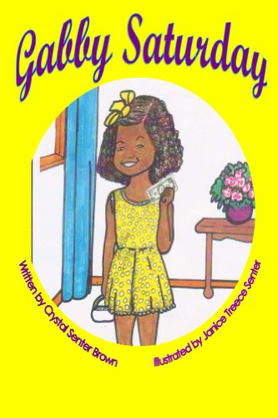
Gabby Saturday
Children’s book, ISBN #978-1496075970
It's Saturday, do you know what that means? It means Gabby gets to wear her yellow dress and put away her jeans! Gabby's Mama is taking her on an adventure...to the museum! The Gabby Saturday series promotes self esteem and literacy among African-American children, specifically young girls.

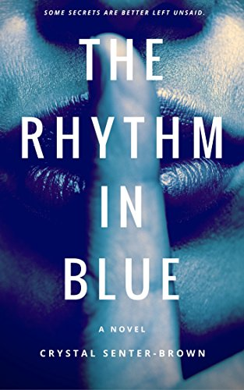
The Rhythm in Blue
Novel, ISBN #978-1497425620
Mason loves his fiancée, but he’s fed up with the stress of planning and preparing for the wedding. Enough already! He needs a few days away. He knows he should have just checked into the nearest hotel, but instead he finds himself driving south. His destination? Jasmine’s house. Aside from that one night many years ago, he and Jasmine have managed to maintain a strictly platonic relationship. A few days away with a friend, he thinks, is just what the doctor ordered. Right?

Bio: Crystal Senter-Brown has been featured in Redbook Magazine, Vibe Magazine and Essence Magazine and has been a performance poet and writer for most of her life. Born in Morristown, TN to a bass-playing Baptist preacher (Dad) and a visual artist (Mom), Crystal performed her first poem onstage at the age of six. Crystal is the recipient of several awards including the 2014 Massachusetts Fellowship in Poetry. She is the author of five books: But Now I See, But You Have Such a Pretty Face, Doubledutch, Gabby Saturday, Gabby Gives Back, and The Rhythm in Blue, which will be released as a full-length movie in March, 2017. She is an adjunct professor at Bay Path University and lives in New England with her husband, son and furry her companion named Venus.
www.gabbysaturday.com
www.crystalsenterbrown.com

