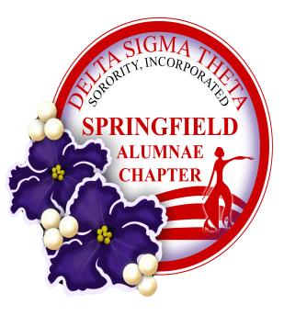
P.O. Box 3622 Springfield, MA 01101

April 10, 2018

Greetings,

The Springfield Alumnae Chapter of the Delta Sigma Theta Sorority, Incorporated will host the 6th Annual Red & White Scholarship Luncheon on Sunday, May 20, 2018 at Chez Josef. Each year we recognize a group of graduating high school seniors who have demonstrated academic excellence and who have matriculated into a college or university to pursue her future career. We will also recognize Women who have excelled in Business, Community and Pubic Service, Education and the Arts. This event will be a “Red Carpet” experience for scholarship recipients and honorees and a time for fellowship and fun for all with door prizes, raffles and the annual Red Shoe Competition and Stroll.

We would like to extend an invitation to you to participate as a vendor at the 6th Annual Red & White Scholarship Luncheon. There, you will have an opportunity to showcase and offer your products to attendees. The vendor registration fee is $50.00 (includes table and table cloth) with a discount option of $25.00 if you contribute a gift basket or item for Raffle or Door Prize. Your donation will be acknowledged in the Event program. Vendor set-up will begin at 11:30 a.m. and breakdown at 4:00 p.m. The Vendor and VIP reception will begin at 1:00 pm and the program will begin at 1:45. The vending area will be open throughout the program.

Please review, complete and mail in the enclosed Vendor Registration Form. The Registration deadline is May 4, 2018. An acknowledgement of receipt of your registration form will be provided. If you have any questions, please feel free to contact me at 413-221-9956 or email mworthy9956@gmail.com.

Sincerely,

Mary B. Worthy
Vendor Registration
6th Annual Red & White Scholarship Luncheon Committee

